Министерство науки и высшего образования Российской Федерации
НАЦИОНАЛЬНЫЙ ИССЛЕДОВАТЕЛЬСКИЙ
ТОМСКИЙ ГОСУДАРСТВЕННЫЙ УНИВЕРСИТЕТ (НИ ТГУ)
Институт прикладной математики и компьютерных наук

ОТЧЁТ ПО ЛАБОРАТОРНОЙ РАБОТЕ №9

по дисциплине «Системы управления базами данных»

Выполнил: Левковский А. Д.
студент группы 932323

Проверил:
Преподаватель
Мокина Е. Е.

Томск – 2024

таблица | DDL индекса | обоснование
Characters ( character_id, name, red_heart, soul_heart, black_heart, eternal_heart, damage, speed ) | CREATE UNIQUE INDEX idx_characters_name_unique ON Characters(name); | уникальный индекс на имя персонажа
Pickups ( pickup_id, name, type, effect_description ) | CREATE UNIQUE INDEX idx_pickups_name_unique ON Pickups(name); | уникальный индекс на имя пикапа
Characters ( character_id, name, red_heart, soul_heart, black_heart, eternal_heart, damage, speed ) | CREATE INDEX idx_characters_hearts_damage ON Characters(red_heart, soul_heart, black_heart, damage); | Составной индекс для поиска персонажей по типам сердец и урону
Pickups ( pickup_id, name, type, effect_description ) | CREATE INDEX idx_pickups_type  ON Pickups(type); | Индекс для быстрого поиска пикапов по типу
Character_starting_pickups ( character_id, pickup_id, amount ) | CREATE INDEX idx_character_starting_pickups_character_id ON Character_starting_pickups(character_id); | Индекс для поля character_id (внешний ключ к таблице Characters)
DROP INDEX idx_characters_name_unique;
DROP INDEX idx_pickups_name_unique;
DROP INDEX idx_characters_hearts_damage;
DROP INDEX idx_pickups_type;
DROP INDEX idx_character_starting_pickups_character_id;

CREATE VIEW v_character_pickup_overview AS  SELECT  c.character_id,  c.name AS character_name,  c.red_heart,  c.soul_heart,  c.black_heart,  c.eternal_heart,  c.damage,  c.speed,  COUNT(DISTINCT cp.pickup_id) AS total_pickup_types,  SUM(cp.amount) AS total_pickup_items,  STRING_AGG(DISTINCT p.name, ', ') AS pickup_names  FROM Characters c  LEFT JOIN Character_starting_pickups cp ON c.character_id = cp.character_id  LEFT JOIN Pickups p ON cp.pickup_id = p.pickup_id  GROUP BY c.character_id, c.name, c.red_heart, c.soul_heart, c.black_heart, c.eternal_heart, c.damage, c.speed  ORDER BY c.character_id; | 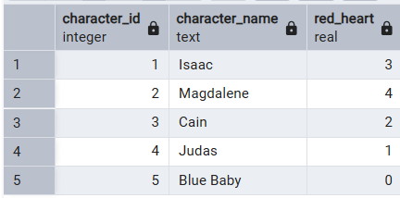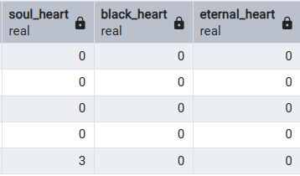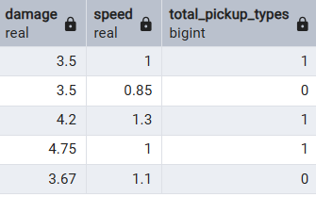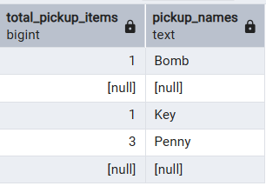 | Полная информация о персонажах и их стартовых пикапах
CREATE VIEW v_pickup_character_details AS  SELECT  p.pickup_id,  p.name AS pickup_name,  p.type AS pickup_type,  p.effect_description,  COUNT(DISTINCT cp.character_id) AS character_count,  STRING_AGG(DISTINCT c.name, ', ' ORDER BY c.name) AS character_names,  AVG(cp.amount)::DECIMAL(5,2) AS avg_amount_per_character,  SUM(cp.amount) AS total_amount,  -- Расчет редкости пикапа (1/количество персонажей, у которых он есть)  CASE  WHEN COUNT(DISTINCT cp.character_id) = 0 THEN 'Never used'  WHEN COUNT(DISTINCT cp.character_id) <= 2 THEN 'Rare'  WHEN COUNT(DISTINCT cp.character_id) <= 4 THEN 'Uncommon'  ELSE 'Common'  END AS pickup_rarity  FROM Pickups p  LEFT JOIN Character_starting_pickups cp ON p.pickup_id = cp.pickup_id  LEFT JOIN Characters c ON cp.character_id = c.character_id  GROUP BY p.pickup_id, p.name, p.type, p.effect_description  ORDER BY p.type, character_count DESC, p.name; | 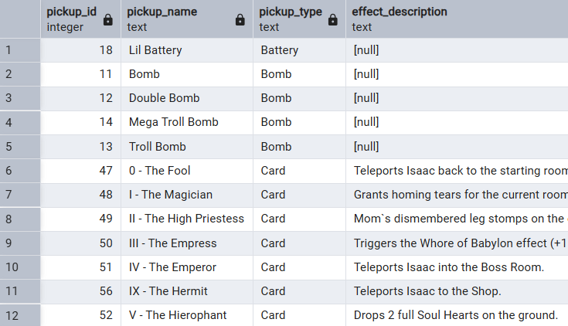 | Детализированная статистика по пикапам
DROP VIEW IF EXISTS v_character_pickup_overview;  DROP VIEW IF EXISTS v_pickup_character_details; |  | удаление

Представления:
CREATE VIEW v_character_pickup_overview AS
SELECT
c.character_id,
c.name AS character_name,
c.red_heart,
c.soul_heart,
c.black_heart,
c.eternal_heart,
c.damage,
c.speed,
COUNT(DISTINCT cp.pickup_id) AS total_pickup_types,
SUM(cp.amount) AS total_pickup_items,
STRING_AGG(DISTINCT p.name, ', ') AS pickup_names
FROM Characters c
LEFT JOIN Character_starting_pickups cp ON c.character_id = cp.character_id
LEFT JOIN Pickups p ON cp.pickup_id = p.pickup_id
GROUP BY c.character_id, c.name, c.red_heart, c.soul_heart, c.black_heart, c.eternal_heart, c.damage, c.speed
ORDER BY c.character_id;

SELECT * FROM v_character_pickup_overview ORDER BY character_id LIMIT 10;

ALTER VIEW v_character_pickup_overview RENAME TO character_pickup_summary;

SELECT * FROM character_pickup_summary WHERE character_id = 1;

DROP VIEW character_pickup_summary;

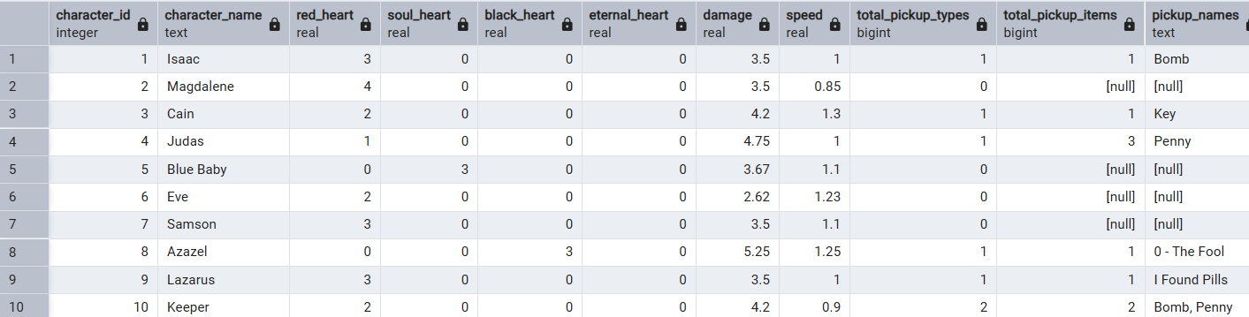

CREATE VIEW v_pickup_character_details AS
SELECT
p.pickup_id,
p.name AS pickup_name,
p.type AS pickup_type,
p.effect_description,
COUNT(DISTINCT cp.character_id) AS character_count,
STRING_AGG(DISTINCT c.name, ', ' ORDER BY c.name) AS character_names,
AVG(cp.amount)::DECIMAL(5,2) AS avg_amount_per_character,
SUM(cp.amount) AS total_amount,
-- Расчет редкости пикапа (1/количество персонажей, у которых он есть)
CASE
WHEN COUNT(DISTINCT cp.character_id) = 0 THEN 'Never used'
WHEN COUNT(DISTINCT cp.character_id) <= 2 THEN 'Rare'
WHEN COUNT(DISTINCT cp.character_id) <= 4 THEN 'Uncommon'
ELSE 'Common'
END AS pickup_rarity
FROM Pickups p
LEFT JOIN Character_starting_pickups cp ON p.pickup_id = cp.pickup_id
LEFT JOIN Characters c ON cp.character_id = c.character_id
GROUP BY p.pickup_id, p.name, p.type, p.effect_description
ORDER BY p.type, character_count DESC, p.name;

SELECT pickup_id, pickup_name, pickup_type, character_count, character_names, pickup_rarity
FROM v_pickup_character_details
WHERE character_count > 0
ORDER BY character_count DESC;

DROP VIEW v_pickup_character_details;

